

Serendib Global Exports Your Trusted Partner for Quality Psyllium Husk,Basmsati Rice,Dates

**Export Excellence: Unveiling India's Natural Riches Serendib Global exports: Your Gateway to Authentic Indian Treasures**

Connecting the World with the Essence of India

**Empowering Global Trade, Enriching Lives**

Based in the serene foothills of Dehradun, Uttarakhand, Serendib Global Exports is your trusted partner in sourcing the finest products from India and delivering them to your doorstep, anywhere in the world. We specialize in exporting premium Psyllium Husk and Basmati Rice, while also facilitating the import of exquisite Dates.

# **Our Commitment:**

At Serendib Global Exports, we provide top-quality products and exceptional service to our clients worldwide.

## **Why Choose Us:**

* **Uncompromising Quality:** We source only the finest materials and adhere to strict quality control measures.
* **Diverse Selection:** We offer a wide range of products to meet your specific needs.
* **Competitive Pricing:** We provide cost-effective solutions without compromising on quality.
* **Timely Delivery:** We ensure prompt and efficient delivery to keep your operations running smoothly.
* **Exceptional Customer Service:** We are here to assist you every step of the way.

**Contact Us:**

* **Serendib Global Exports Pvt Ltd**
* F-3, Capital Plaza, ITBP Road, Niranjanpur, Dehradun, Uttarakhand, India
* **Email:** [serendibglobalexports@gmail.com](mailto:serendibglobalexports@gmail.com)
* **Phone:** +91 9760077178, +91 7535041668

**Website:** www:serendibglobalexports.com **Product Highlights:**

**Partner with us today and experience the difference! 1. Psyllium Husk**

Psyllium husk, also known as isabgol, is a type of fiber derived from the seeds of the Plantago ovata plant. It's a popular dietary supplement due to its numerous health benefits. Here's a breakdown of its varieties and uses:

**Varieties**

* **Whole Psyllium Husk:** This is the most natural form, containing both soluble and insoluble fiber. It's commonly used as a bulk-forming laxative.
* **Psyllium Powder:** This is a finely ground version of the husk, often used in supplements and as an additive in food products.
* **Psyllium Capsules:** These are convenient for those who dislike the taste or texture of the powder or husk.
* **Key Product Features**Specifications

| **Parameters** | **Value** |
| --- | --- |
| Purity | 99.5% / 99% / 98% |
| Color | Light brown to moderate brown |
| Odor | Faint, characteristic |
| Taste | Bland, mucilaginous |
| Particle Size | Maximum 5.0 % on U.S.S. 35# |
| Moisture (loss on drying) | Maximum 12.0 % |
| Total Ash | Maximum 4.0 % |
| Acid Insoluble Ash | Maximum 1.0% |
| Foreign Organic Matter | Maximum 0.5 % |

**Basmati Rice**

* **Pusa Basmati 1121 (8.35mm):**
  + Extra-long, slender grains with a pearly white color.

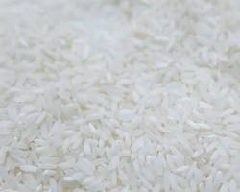

Pusa Basmati 1121 rice grains, uncooked and cooked

* + Delicate aroma and a soft, fluffy texture when cooked.
  + Ideal for special occasions, biryanis, and pulaos.
  + Available in Steam, White/Creamy Sella, and Golden Sella processing types.
  + Pesticide Residue Free options available for USA and EU norms.
* **Pusa Basmati 1509 (8.40mm):**
  + Long grains with a pleasant aroma.

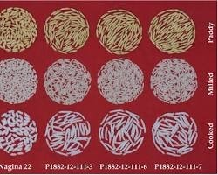

Pusa Basmati 1509 rice grains, uncooked and cooked

* + Cooks quickly and evenly, perfect for everyday meals.
  + Available in Steam, White/Creamy Sella, and Golden Sella processing types.
  + Pesticide Residue Free options available for USA and EU norms.
* **Traditional Basmati (Dehraduni) (7.25mm):**
  + Slender grains with a distinct, earthy aroma.

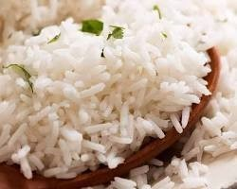

Traditional Basmati rice grains, uncooked and cooked

* + Authentic taste and texture, ideal for traditional Indian dishes.
  + Available in Raw/White and White/Creamy Sella processing types
  + .
* **1401 Basmati Rice (7.70 MM):**
  + Medium-long grains with a subtle aroma.

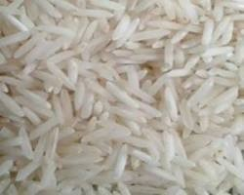

1401 Basmati rice grains, uncooked and cooked

* + Versatile for various rice dishes and cuisines
  + Available in Steam, White/Creamy Sella, and Golden Sella processing types.
  + Pesticide Residue Free options available for USA and EU norms
* **Pusa Basmati Rice (7.45 MM):**
  + Medium-long grains with a delicate aroma

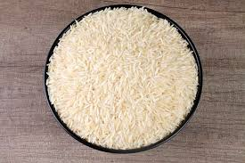

Pusa Basmati rice grains, uncooked and cooked

* + Cooks to a soft and fluffy texture
  + Available in Raw/White, Steam, White/Creamy Sella, and Golden Sella processing types
  + Pesticide Residue Free options available for USA and EU norms

**Export**

**Basmati Rice**

* **1121 Basmati Rice (8.35mm):** *
  + Extra-long, slender grains with a pearly white color
  + Delicate aroma and a soft, fluffy texture when cooked
  + Ideal for special occasions, biryanis, and pulaos
  + Available in:
    - Raw/White
    - Steam
    - White/Creamy Sella
    - Golden Sella
  + Pesticide Residue Free options available for USA and EU norms
* **1509 Basmati Rice (8.40mm):** *
  + Long grains with a pleasant aroma
  + Cooks quickly and evenly, perfect for everyday meals
  + Available in:
    - Steam
    - White/Creamy Sella
    - Golden Sella
  + Pesticide Residue Free options available for USA and EU norms
* **1401 Basmati Rice (7.70 MM):** *
  + Medium-long grains with a subtle aroma
  + Versatile for various rice dishes and cuisines
  + Available in:
    - Steam
    - White/Creamy Sella
    - Golden Sella
  + Pesticide Residue Free options available for USA and EU norms
* **Pusa Basmati Rice (7.45 MM):** *
  + Medium-long grains with a delicate aroma
  + Cooks to a soft and fluffy texture
  + Available in:
    - Raw/White
    - Steam
    - White/Creamy Sella
    - Golden Sella
  + Pesticide Residue Free options available for USA and EU norms
* **Traditional Basmati Rice (7.25 MM):** *
  + Slender grains with a distinct, earthy aroma
  + Authentic taste and texture, ideal for traditional Indian dishes
  + Available in:
    - Raw/White
    - White/Creamy Sella

**Dates**

* **Medjool:**
  + Large, plump, and soft with a rich, caramel-like flavor

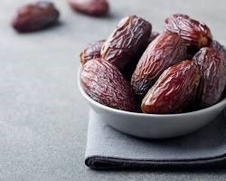

Medjool dates

* + Often considered the "king of dates"
  + Ideal for snacking, desserts, and gifting
* **Deglet Noor:**
  + Semi-dry, chewy, with a subtle sweetness and a hint of nuttiness

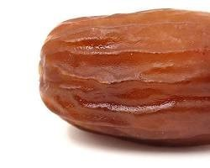

Deglet Noor dates

* + Versatile for snacking, baking, and adding to salads
* **Ajwa:**
  + Small, dark brown, and slightly sweet with a unique flavor

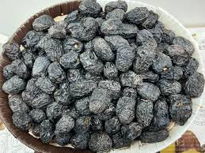

Ajwa dates

* + Traditionally associated with health benefits
  + Popular during Ramadan and for gifting
* **Zahidi:**
  + Semi-dry, firm texture, with a golden brown color

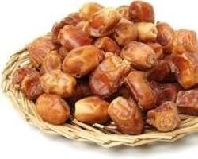

Zahidi dates

* + Mildly sweet and versatile for various uses
* **Khadrawy:**
  + Soft, sweet, with a golden color and a slightly chewy texture

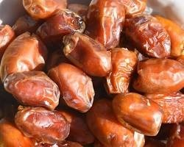

Khadrawy dates

* + Popular for snacking and adding to desserts
* **Barhi:**
  + Small, round, and golden-yellow with a honey-like flavor

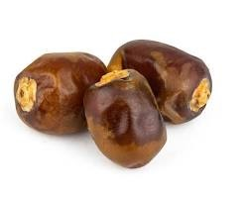

Barhi dates

* + Delicate and less common variety
* **Mabroom:**
  + Long, cylindrical, dark brown with a rich, toffee-like flavor

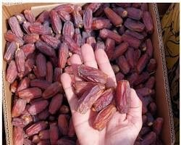

Mabroom dates

* + Less sweet than other varieties, suitable for savory dishes
* **Safawi:**
  + Soft, dark brown, with a sweet, caramel flavor

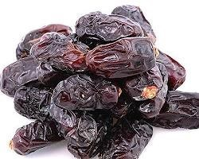

Safawi dates

* + Popular for snacking and adding to desserts

# About Us Page

* **Our Story:**
* Serendib Global Exports is a dynamic startup , fueled by a passion for facilitating global trade and providing premium products to customers worldwide. Our commitment to quality, sustainability, and customer satisfaction sets us apart.
* **Team:**
* Meet our dedicated team:
  + Farhat Abbas, Founder & CEO
  + Mohd Aamir, Export Manager
  + HaiderAli, Import Manager



* **Our Values:**
  + Integrity: We operate with the utmost honesty and transparency in all our business practices.
  + Excellence: We strive for continuous improvement and aim to exceed expectations in everything we do.
  + Customer Focus: We listen to our clients' needs and provide personalized solutions to ensure their complete satisfaction
  + Collaboration: We believe in the power of collaboration and work together with our partners to achieve mutual success.
  + Sustainability: We're committed to responsible business practices that protect the environment and support local communities.